
Company
Logotype

Cone Beam Computed Tomography- Report



Porur Dental X-rays & CBCT

Patient Name : Mr. Venkatesh | Date of Report : 12.08.2024
Age/ Gender : 26 years/ Male | Region of Interest : CBCT Anterior Maxilla
Referring doctor: Dr. Selva Ganesh | Indication : Periapical lesion: 11, 12
Clinical Notes: Nil
PATIENT INFORMATION

CBCT Anterior Maxilla provided
CBCT – IMAGE DETAILS

RADIOGRAPHIC INTERPRETATION

- The teeth 11 and 12 are present with normal enamel, dentin pulp, PDL space and periapical region.
- In relation to the periapical aspect of 21, 22 periodontal ligament space widening and presence of a diffuse periapical hypodense area measuring 5.73 x 11.06 x 6.75mm and 5.9 x 5.7 x 11.07mm respectively, with ill-defined margins is evident. The tooth 21 is present with open apex.
- The hypodense area appears to cause thinning of the palatal cortical plate and lies in close proximity to the nasal floor and incisive canal.

RADIOGRAPHIC IMPRESSION

- Differential Diagnosis (based on the visible radiological features): Periapical pathology in relation to 21, 22.


Kindly correlate with clinical and histopathological features

IMAGES FOR REFERENCE

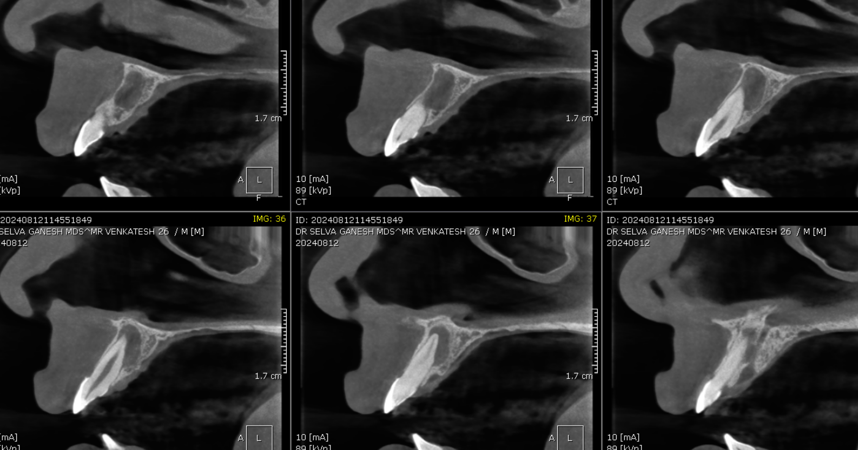
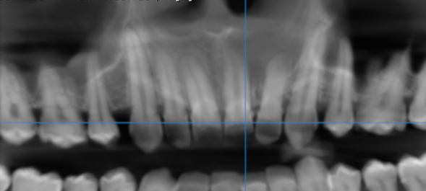
RECONSTRUCTED PANORAMIC VIEW
SAGITTAL IMAGES FOR REFERENCE
CORONAL IMAGES FOR REFERENCE
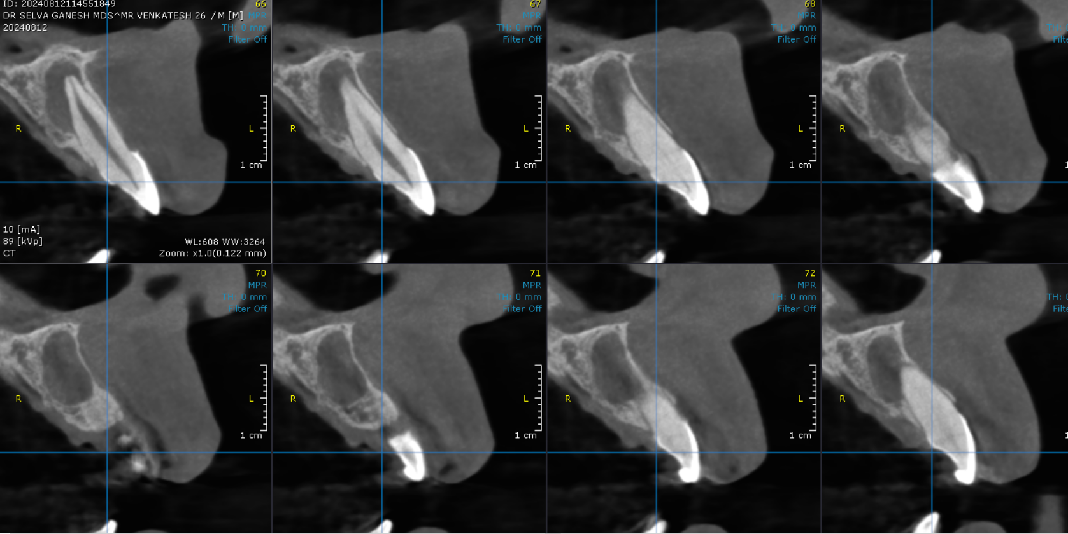
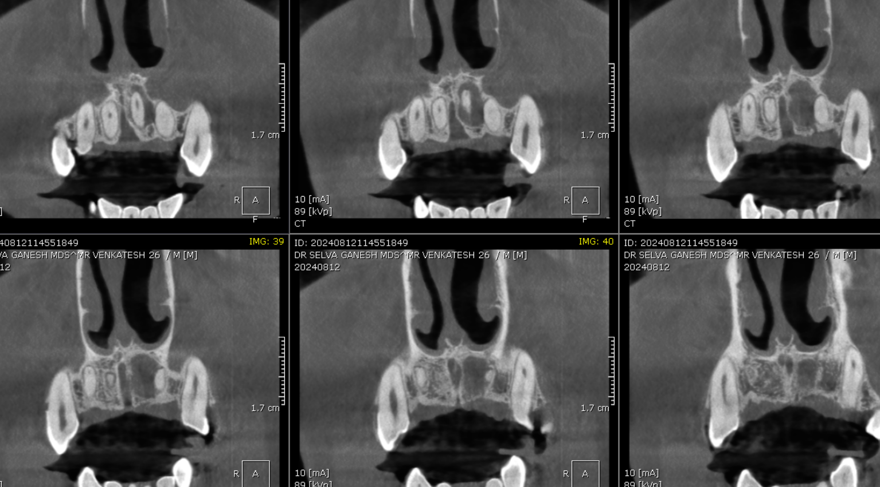
CROSS SECTIONAL IMAGES FOR REFERENCE

3-DIMENSIONAL VIEW

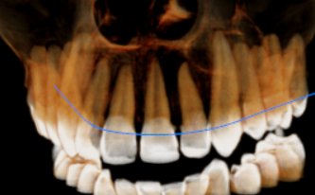

**** End of report ****

